# **FROM 8st June TO 18th June**

# **Project ID:**

# **2021J_BV01_BCI Browser**

# **Project Title:**

# **Design and development of Brain Computer Interface Browser on Web and Mobile**

# **Summary:**

* Steady state visual evoked potential (SSVEP)- based brain-computer interface (BCI) has gained a lot of attention due to its robustness and high information transfer rate (ITR). However, transitioning well-controlled laboratory oriented BCI demonstrations to real-world applications poses severe challenges for this exciting field. For instance, conducting BCI experiments usually requires skilled technicians to abrade the area of skin underneath each electrode and apply an electrolytic gel or paste to acquire high-quality SSVEPs from hair-covered areas.
* This study proposed an alternative approach that employed electroencephalographic signals collected from easily accessible non-hair-bearing areas including neck, behind the ears, and face to realize an SSVEP-based BCI. The study results showed that, with proper electrode placements and advanced signal-processing algorithms, the SSVEPs measured from non-hair-bearing areas in off-line SSVEP experiments could achieve comparable SNR to that obtained from the hair-bearing occipital areas.
* This study extended the previous work to systematically investigate the costs and benefits of non-hair SSVEPs. Furthermore, this study developed and evaluated an online BCI system based solely on non-hair EEG signals. A 12-target identification task was employed to quantitatively assess the performance of the online SSVEP-based BCI system.
* The empirical results of this study demonstrated the practicality of implementing an SSVEP-based BCI based on signals from non-hair bearing areas, significantly improving the feasibility and practicality of real-world BCIs.

# 

# **Detail:**

# **Detailed methodology used**

STEADY-STATE visual evoked potential (SSVEP), the brain’s natural electrophysiological response to repetitive visual flickering, has been widely used in the fields of neural engineering and neuroscience . In electroencephalogram (EEG)-based brain-computer interfaces (BCIs), the SSVEP-based BCI has attracted much attention due to its advantages of high performance and rapid user training.

Despite the success in improving the accuracy and speed of SSVEP-based BCIs, moving BCI systems from a well controlled laboratory setting to a real-life environment remains extremely challenging due to the complications of measuring EEG outside well-controlled laboratory settings. Current BCI operations require extensive subject preparation including scalp abrasion, gel application, and tethered electrodes . Developing a truly practical SSVEP-based BCI system evidently requires significant improvements in measuring EEG signals. Some efforts have been made to overcome these technical barriers of the EEG measurement in the past few years .

For instance, studies have shown that dry-contact and noncontact electrodes can avoid the usage of conduct gels. These electrodes can simply be placed over the hair-covered areas to acquire EEG signals from the scalp without requiring skin preparation or conductive gels. However, a major concern over the use of dry, nonprep electrodes for the EEG measurement is that the signal-to-noise rate (SNR) of the acquired signals might not be as good as that obtained from the gel-based wet electrodes. Furthermore, for some clinical applications such as patients lying face up, measuring EEG from the occipital sites would be undoubtedly more difficult either by wet or dry electrodes . Therefore, an alternative approach to robustly measure high-quality SSVEPs becomes imperative. **Non-hair bearing areas including neck, face, and behind the ears can be alternative locations to acquire EEGs without requiring skin preparation or the use of conduct gels** .

The empirical results of the study showed that SSVEPs could be assessed from those non-hair-bearing areas, and more importantly with a proper electrode selection the SNR of the SSVEPs could be comparable or even higher than that obtained by the wet electrodes placed over the occipital areas. However, the study only tested the SNRs of non-hair SSVEPs on a small group of five subjects.

More recently, an online SSVEPbased BCI system using in-the-ear EEGs and the system performance reached 16.6±6.55 bits/min . Independently, Norton et al. also proposed a soft and curved electrode system that is capable of acquiring EEGs from auricles. The system provided long-term recording of EEG data by intimately attaching the soft electrode to the complex surface of the ear. The result of the SSVEP experiment in the study showed an ITR of 12 bits/min. In summary, although the advanced sensing technologies enabled a new apparatus for acquiring EEGs, the resultant ITRs were not nearly as good as those reported in recent high-speed BCI studies based on occipital EEGs . However, because there are considerable differences across the studies using non-hair and occipital EEGs in terms of stimulus coding mechanism, experimental design and setup, electrode positions and subject pools, it is difficult to directly compare results between non-hair and occipital SSVEPs. In other words, the cost and benefits of using non-hair SSVEPs compared to that using the occipital SSVEPs remains unclear.

A concurrent recording of both nonhair and occipital SSVEPs for each individual is required to quantitatively compare the differences in BCI performance between two montages. This study aims to explore the feasibility and benefit of using EEG data from non-hair-bearing areas, along with the aforementioned advanced stimulus-coding and target identification methods, to develop and test an online SSVEPbased BCI system. We first explored the scalp distributions of the SNRs of the SSVEPs collected from the offline BCI experiments, and then compared the SNRs of SSVEPs measured by different combinations of electrodes placed over four scalp regions, including neck, face, behind-the-ear, and occipital areas. The CCA-based spatial filtering method was then used to enhance the SNRs of SSVEPs. In addition to the offline analysis, an online BCI experiment was conducted to evaluate the performance of a 12-target SSVEP-based BCI using solely non-hair-bearing electrodes. In the online BCI experiments, the aforementioned hybrid frequency and phase coding method and the extended CCA-based methods that incorporate individual training data and filter bank method were used to optimize the BCI performance.

**Data Acquisition**

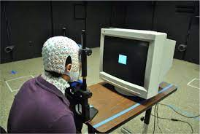

Subject wore a 256-channel EEG recording system (includes a cap and a neck band) and gazed at a visual stimulus with his head resting on a chin rest. Note that all the cables were removed temporarily in order to have a clean view.

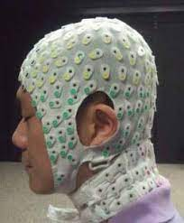

Subject wore a 256-channel EEG cap including a neck band. The red, black, green, and blue circles roughly delineate the occipital, behind-the-ear, face, and neck areas, respectively. Note that one or two external electrodes were inserted into the gap between behind-the-ear and EEG cap since the cap might not fit each individual’s head.

# 

# 

# 

In order to find the best electrode combination, the process of electrode selection was applied to recordings from each area. Eight electrodes were randomly selected for each area, and the SNRs were calculated using these electrodes after spatial filtering. The electrode selection was repeated 50 000 times for each area, and then the electrode combination that produces the highest SNR was noted and used for the following analysis.

**Target Identification:**

This study also compared target identification accuracy and simulated ITRs using a 5- class SSVEP dataset measured from four different areas. The SSVEP signals were first down-sampled to 256 Hz. The performances were evaluated by the filter bank analysis proposed in [13] and the extended CCA analysis

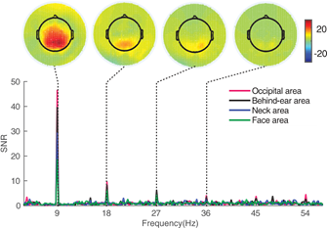

SNR distribution of a sample subject gazing at a 9 Hz visual stimulus. The topographic maps at the top (left to right) panels are the 2-D SNR distribution at the fundamental frequency, second harmonics, third harmonics, and fourth harmonics, respectively.

# 

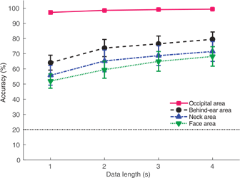

Figure shows the average accuracy across all subjects for the five-target classification using the best combination of electrodes in each area across different data lengths from 1 to 4 s. In general, the accuracy of SSVEP detection increased as the data length increased. The occipital area achieved over 95% in classification accuracy even with a short data length.

**In summary, results from high-density EEG recordings provided invaluable insights into the optimal channel selection:the electrodes near the occipital lobe (e.g., behind the ear and neck) were the best candidates to build an SSVEP-based BCI system based on non-hair-bearing montage. Considering that the muscle activities might contaminate the signals measured from the neck area, signals measured behind the ear areas seem to be the better choice of an online SSVEP-based BCI.**

**Analysing EEG data for P300 speller system using Support Vector Machines (SVM) classification technique**

Using the SVM classification method, we are able to find a correct and faster solution for the “target character detection” associated with the P300 speller system. The method requires minimal pre-processing and provides a high transfer rate, which makes it suitable for online analysis also. This new method was introduced because the practice implementation of P300 is still quite challenging because of the following reasons:-

1. EEG recording is still a very inconvenient task (especially for lengthy multi-trial acquisition)

2. Less reliability in the system

3. Slow transfer rate

4. Complexity in stimulation

5. Poor accuracy

6. Increasing classification challenges

A Gaussian kernel based Support Vector Machine(SVM) classification algorithm is used that can accurately detect the target character in relatively less number of trials. Necessity of less number of trials results in better accuracy training session. The decimated and filtered amplitude values of been taken as feature coefficients for classification. The decimation process converts the lengthy signals into effective but compact and lesser dimensional feature vector. This results in faster classification and requires lesser size of training data. As a result, we are able to provide comparatively higher communication bit rate and classification accuracy.

**DATA SET FOR EXPERIMENTAL ANALYSIS**

Dataset used- The 2nd Wadsworth BCI dataset

It provides the record of P300 evoked potentials recorded with BCI2000 using the 6X6 sized matrix display paradigm.

The EEG signals were acquired using a standard 10-20 electrode placement system with 64 electrodes. The EEG signals were recorded from one subject in 3 sessions (viz. Session 10, 11 and 12), where each session was divided into number of runs. During the data recording, the user’s task was to focus on a particular target character out of 36 different characters. All the rows and columns of this matrix were randomly and successively intensified for 100 ms (followed by a 75 ms blank period).The intensification was block randomized in a set of 12. 2 out of 12 such intensification contain the target character. This block randomization was repeated for 15 times for each target character.

For each run of session 10 and 11, the information of actual EEG signals (sampled at 240 Hz), StimulusCode(row/column number intensified) and StimulusType(the class label of signals containing target character) were provided. For session 12, StimulusType information was not provided. The user’s task was to predict the target word for each run of session 12.

**METHODOLOGY:-**

For each block of intensification of 12 rows/columns,we have to identify one row and column,which has the stimulating character(i.e. Target character). For this binary classification problem(of detecting the presence of P300 ERP Component in the signal sequence),we have trained a SVM classifier. As the recorded evoked potentials are very noisy and include the background brain activities,it is not possible to detect the target character from just one trail. Hence ,we have applied a multi-trial classification approach for detecting the target character. Based on the majority voting of the rows/columns , the row and column number which is supposed to have the desired character is decided. The process is divided into 3 stages:-

**A.Data Preprocessing and Feature Vector Generation**

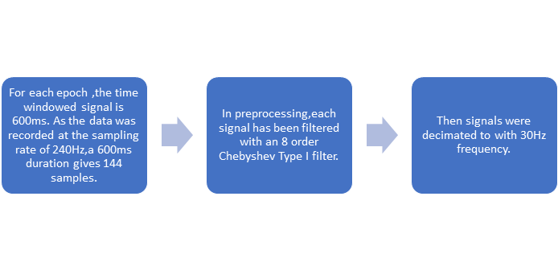

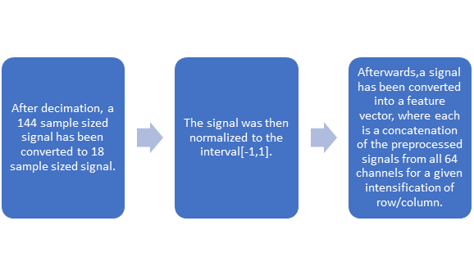

# Hence, the size of a feature vector is 64×18=1152. Thus for a single character, the training set is composed of 180 (12 intensifications of rows/columns × 15 trials) feature vectors. In these 180 feature vectors, 30 are from class +1 (2 from each block of 12 × 15 trials) and remaining 150 are from class -1.

We have used all the characters from all the runs of session 10 and 11 to prepare the training set. There are total 42 characters in session 10 and 11, so the training set consists of 7560 feature vectors (42×180), where each feature vector is of size 1152. Out of these 7560 feature vectors, 1260 vectors are from class +1 and remaining 6300 from class -1.

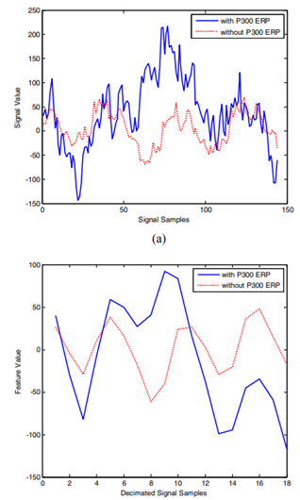

Figure-: (a) The sample variation of the raw signals (144 samples) with P300 ERP in blue color (class +1) and without P300 ERP in dotted-red (class label - 1). (b) Corresponding sample variation of the pre-processed normalized signals. The plot is provided for the average of all the class +1 and class -1 signals of channel number 13 of run 1 of session 10. In both the images (a) and (b), we can notice that there is a positive going peak in the class +1 (blue) signals at around 300 ms after the stimulation. This shows the presence of P300 ERP.

**B. Training SVM classifier-** The SVM classifier is based on the concept of providing the better generalizing capabilities of machines for classification. A better generalizing capabilities of a classification algorithm indicates that a classifier has higher chances to perform equally well for the samples outside the training dataset. Equation is given by w.x+b=0. This hyper-plane is a separating hyper-plane between the two parallel hyper-planes of w.x+b=1 and w.x+b=-1

**C. Detection of target character in test data-** Data is too noisy to obtain the correct symbol from only a single trial. So deal with this problem we applied a multi-trial approach. After each trial, we added +1 to the score of each row/column detected in class +1. After n number of trials, one out of size rows and one out of six columns (with the highest score in all rows and columns respectively) was classified to contain the desired character. The desired character was then inferred from the matrix.

**RESULT:** Using a 5-fold cross validation on training set, we are able to obtain 89.79 % accuracy with Gaussian Kernel SVM and 84.72% accuracy with linear SVM.



**DISCUSSION:-** The aim of this research work was to provide an efficient P300 speller system that addresses the issues of user inconvenience, poor accuracy of classification and slow transfer rate. In this regards, a novel technique based on supervised SVM classifier has been proposed. we have extracted the features based on the amplitude of the EEG signals, which turns out to be very simple and affective set of features for classification. Another advantage of our method is low computation complexity, which makes the proposed method suitable for online applications. Finally, using the combination of easily extractable feature set and low processing requirement, we are able to achieve high communication rate, thus successfully addressing the issue of low transfer rate.

# **Conclusion:**

1. This study demonstrated the feasibility and practicality of using non-hair-bearing electrodes to build an online SSVEP-based BCI application. Possible future directions of this study could be reducing the number of non-hair bearing electrodes, optimizing electrodes combinations, and increasing the number of targets in real-world BCI applications such as a BCI speller.
2. A SVM based P300 speller system is used. The efficiency of the algorithm has been proven by applying it on widely used BCI competition dataset.
3. FUTURE ASPECT- At the cost of increase computation (and hence with decreased transfer rate), an improvement in the classification performance may be achieved by using more complex set features. Selecting the set of most relevant channels (for classification) from all 64 channels may also lead to better performance and can be considered as the future work for the presented method.

# **References:**

1.) An Online Brain-Computer Interface Based on SSVEPs Measured From Non-Hair-Bearing Areas Yu-Te Wang, Member, IEEE, Masaki Nakanishi, Member, IEEE, Yijun Wang, Member, IEEE, Chun-Shu Wei, Student Member, IEEE, Chung-Kuan Cheng, Fellow, IEEE, and Tzyy-Ping Jung, Fellow, IEEE

2.) An Efficient P300 Speller System for BrainComputer Interface Rahul Kumar Chaurasiya1 *, Narendra D. Londhe2 , Subhojit Ghosh2 1 Department of Electronics and Telecommunication, 2 Department of Electrical Engineering, National Institute of Technology-Raipur, Raipur-India-492010 * (Corresponding Author), 1 rkchaurasiya@nitrr.ac.in